

**Semester One Examination 2017**

**Question/Answer Booklet**

**MATHEMATICS SPECIALIST**

**UNIT 3**

**Section One:**

**Calculator-free**

|  |
| --- |
| Student Name: _____________________________________ |
| Teacher‘s Name: _____________________________________ |
|  |

**Time allowed for this section**

Reading time before commencing work: five minutes

Working time for paper: fifty minutes

**Material required/recommended for this section**

**To be provided by the supervisor**

This Question/Answer booklet

Formula Sheet

**To be provided by the candidate**

Standard items: pens(blue/black preferred), pencils(including coloured), sharpener, correction tape/fluid, erasers, ruler, highlighters

Special Items: nil

**Important note to candidates**

No other items may be taken into the examination room. It is **your** responsibility to ensure that you do not have any unauthorised notes or other items of a non-personal nature in the examination room. If you have any unauthorised material with you, hand it to the supervisor **before** reading any further.

**Structure of this paper**

|  |  |  |  |  |  |
| --- | --- | --- | --- | --- | --- |
|  | Number of questions available | Number of questions to be attempted | Suggested working time (minutes) | Marks available | Weighting |
| **Section One**  **Calculator—free** | **7** | **7** | **50 minutes** | **50** | **35%** |
| Section Two  Calculator—assumed | 11 | 11 | 100 minutes | 100 | 65% |
|  | | | | 150 | 100% |

**Instructions to candidates**

1. The rules for the conduct of Western Australian external examinations are detailed in the *Year 12 Information Handbook 2017.* Sitting this examination implies that you agree to abide by these rules.
2. Answer the questions according to the following instructions.

Section One: Write answers in this Question/Answer Booklet. Answer **all** questions.

**Show all your working clearly.** Your working should be in sufficient detail to allow your

answers to be checked readily and for marks to be awarded for reasoning. Incorrect

answers given without supporting reasoning cannot be allocated any marks. For any

question or part question worth more than two marks, valid working or justification is

required to receive full marks. If you repeat an answer to any question, ensure that you

cancel the answer you do not wish to have marked.

It is recommended that you **do not use pencil**, except in diagrams.

1. You must be careful to confine your responses to the specific questions asked and to follow any instructions that are specific to a particular question.
2. Spare pages are included at the end of this booklet. They can be used for planning your responses and/or as additional space if required to continue an answer.

* Planning: If you use the spare pages for planning, indicate this clearly at the top of the

page.

* Continuing an answer: If you need to use the space to continue an answer, indicate in the original answer space where the answer is continued, i.e. give the page number. Fill in the number of the question that you are continuing to answer at the top of the page.

1. The Formula Sheet is **not** handed in with your Question/Answer Booklet.

# Section One: Calculator–free 50 marks

This section has **seven (7)** questions. Attempt **all** questions. Write your answers in the spaces provided.

Working time: 50 minutes

**Question 1 (6 marks)**

Consider the complex polynomials $P\left(z\right)=2z^{3}-4z^{2}+8z-16$ and $Q\left(z\right)=z-2i$.

(a) Show that $z-2i$ is a factor of $P(z)$. (2 marks)

(b) State the other complex root of $P(z)$, and hence fully factorise $P(z)$. (4 marks)

**Question 2 (6 marks)**

Consider the function $f\left(z\right)=z^{5}-32i$.

(a) Determine the roots of $f(z)$ in the format $z=r\operatorname{cis}{θ}$ where $r>0$ and $-π<θ<π$.

(4 marks)

(b) Sketch the roots found in (a) on the polar grid provided below. (2 marks)

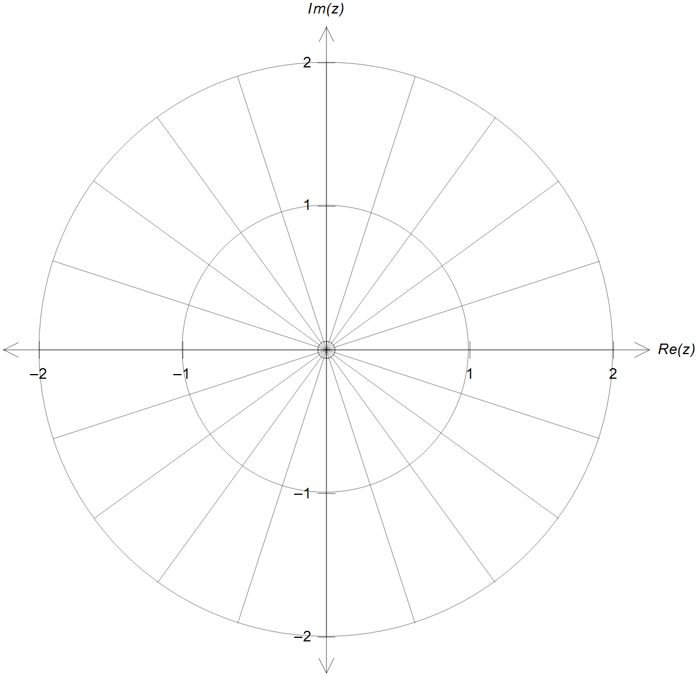

**Question 3(6 marks)**

The graph below shows the function $y=a-\left|x+b\right|$ for specific values of $a$ and $b$.

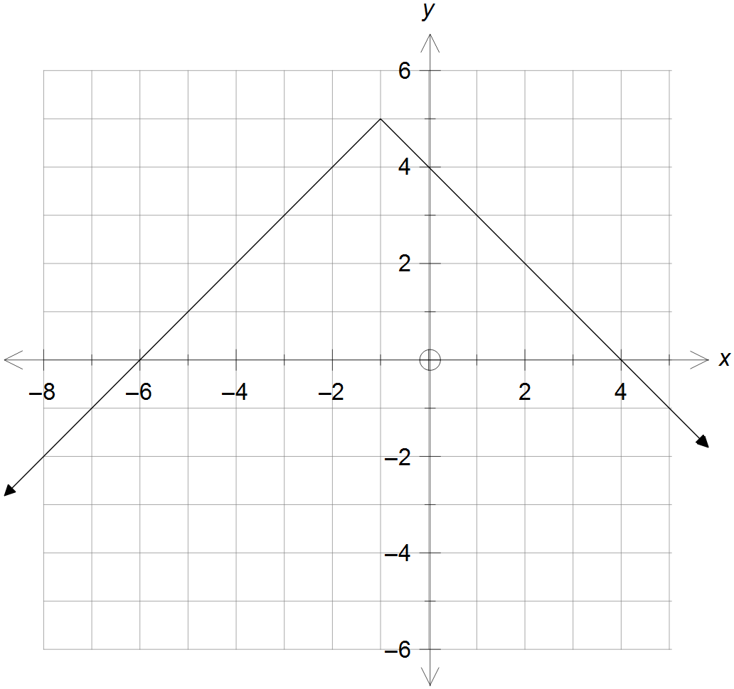

(a) Add the graph of $y=\left|x+2\right|-1$ on the same set of axes above. (2 marks)

(b) State the value of $a$ and $b$ if the equation $\left|x+2\right|-1=a-\left|x+b\right|$ has:

(i) only one solution. (2 marks)

(ii) the solution set $-2≤x≤2$. (2 marks)

**Question 4 (12 marks)**

The function $f(x)$ is defined as $f\left(x\right)=\frac{1}{1+x}$ for its natural domain.

The function $h(x)$ is defined as $h\left(x\right)=f∘f(x)$.

(a) State the conditions on the domain of $f(x)$ so that $h(x)$ exists.

Hence, determine the range of $h(x)$. (5 marks)

**Question 4 (Continued)**

(b) Find a simplified expression for $h\left(x\right)$, and hence sketch it on the axes provided below.

(4 marks)

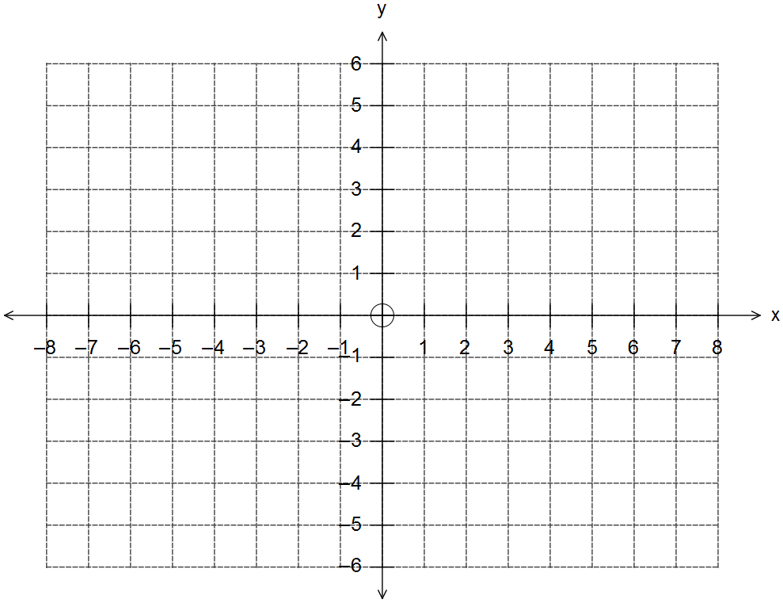

(c) Determine the equation of $h^{-1}(x)$, the inverse of $h(x)$, and state its domain and range.

(3 marks)

**Question 5 (6 marks)**

Consider the planes given by the equations below, where $a∈R$.

$r∙\left(\begin{matrix}2 \\ 1 \\ 1\end{matrix}\right)=1$ $r∙\left(\begin{matrix}0 \\ 4 \\ 2\end{matrix}\right)=2$ $r∙\left(\begin{matrix}3 \\ 1 \\ a\end{matrix}\right)=8$

(a) When $a=-1$ the three planes intersect at single point.

Use an analytical method to determine this unique point of intersection of the three planes.

(3 marks)

**Question 5 (Continued)**

(b) Determine the value of $a$ so that all three planes do not intersect at any specific point.

(3 marks)

**Question 6 (8 marks)**

$$O$$

$$A$$

$$B$$

$$C$$

$$D$$

$$E$$

$$F$$

$$G$$

In the diagram shown, $OAEBCDFG$ is a cube with

the origin at vertex $O$.

Let $i$, $j$ and $k$ be the unit vectors along the $OB$, $AO$

and $CO$ respectively, as shown, with

$$i$$

$$j$$

$$k$$

$\left|OA\right|=\left|OB\right|=\left|OC\right|=4$.

(a) Determine the vector equation of the sphere that has $AG$ as a diameter. (4 marks)

**Question 6 (Continued)**

(b) Determine the vector equation of the plane that contains the vertices $A, F$ and $B$,

in the format $r∙n=k$. (4 marks)

**Question 7 (6 marks)**

A particle moves along the ellipse shown below such that it’s position vector $r(t)$ at any time $t$ is given by:

$$r\left(t\right)=2\cos{(t)}i+\sin{(t)}j$$

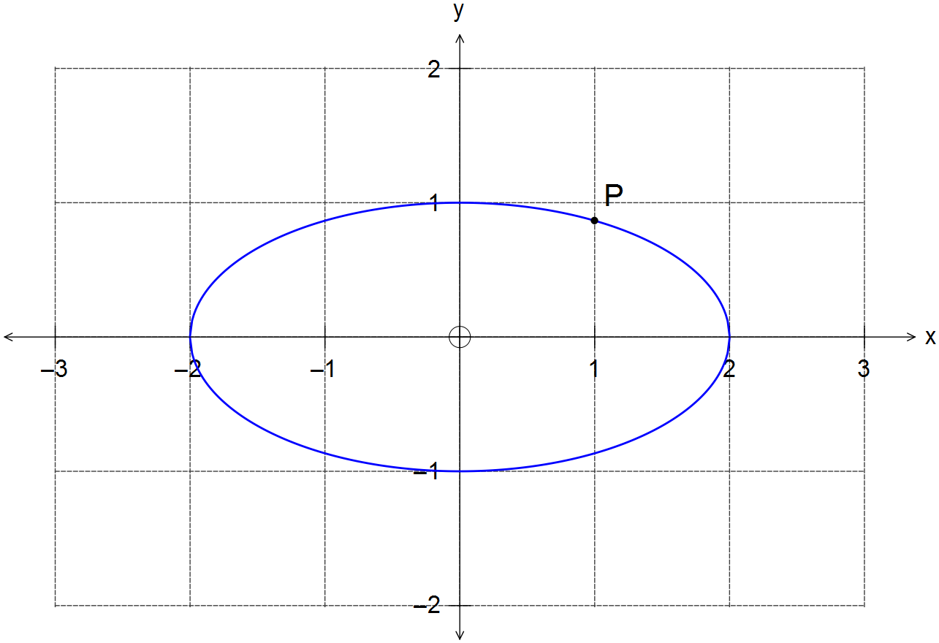

(a) Determine the Cartesian equation of the elliptical path traced by the particle. (2 marks)

(b) Determine the velocity vector of the particle at the point P shown, where $x=1$.

Show the direction of motion of the particle at this instant. (4 marks)

**End of Section 1**

**Additional working space**

Question number(s): ……………………

**Additional working space**

Question number(s): ……………………

**Additional working space**

Question number(s): ……………………

WATP acknowledges the permission of School Curriculum and Assessment Authority in

providing instructions to students.